Measurement of Voltage and Current for a small (35ft) sailing boat

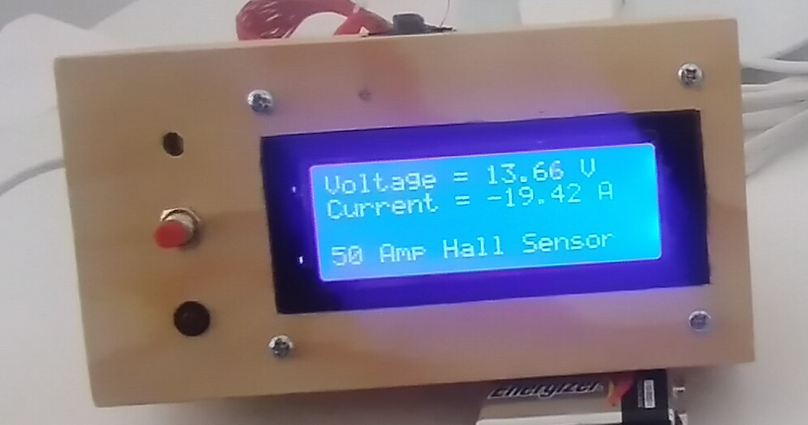
View of the cover of a small box where the various parts are installed.

This gadget measures and displays every second the boat service battery bank voltage and the current to the main 12VDC switchboard. While sailing the batteries are drained and must be recharged after sometime. Knowing the current consumption is important. The Hall sensor has the following advantages over the classic system of measuring the voltage drop across a resistor in series with the 12VDC supply to the switchboard:

a) Does not require any installation, you just open the Hall sensor and put it around the supply cable. (check first if the outside diameter of the cable fits inside the Hall sensor).

b) If the current is above the sensor limit it saturates but there is no damage (may happen if you start the electrical anchor winch)

Besides measuring voltage and current this gadget has on the left side an LED and a buzzer (behind the hole in the top left of the box) for alarming when the voltage reaches 12VDC (or whatever voltage is defined by the program) and a pushbutton to cancel the alarm and also to test the LED and the buzzer.

Layout of the test prototype for measuring voltage and current

If it passes the onboard tests a final arrangement will be made with completely different layout and possibly some changes to the parts used.

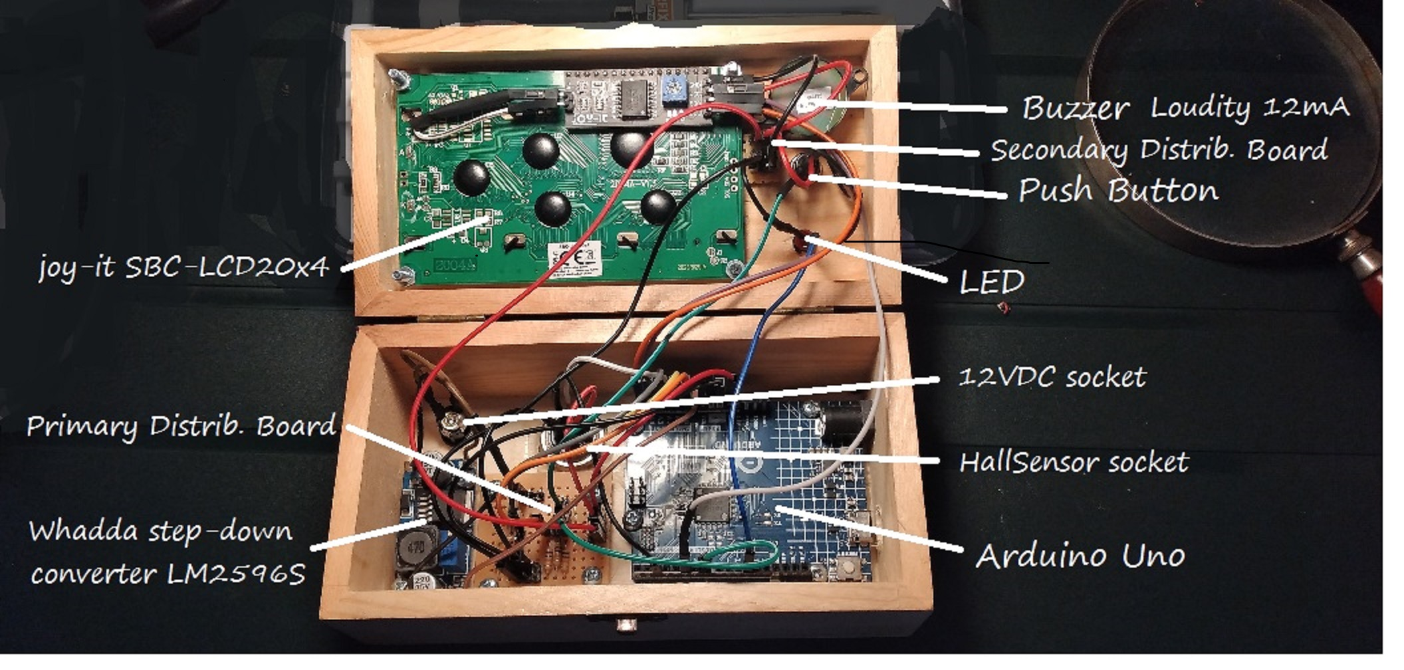
Box and main parts

(back view here to show sockets from the outside)

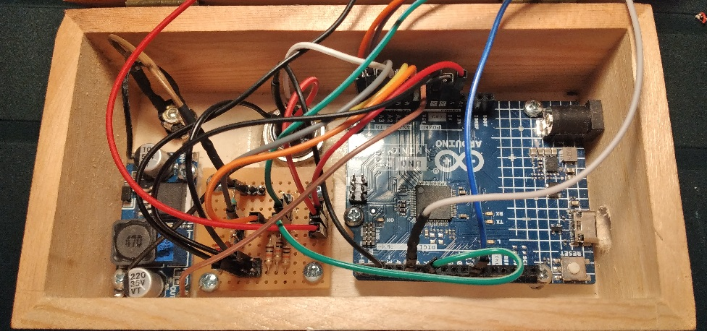
Box bottom

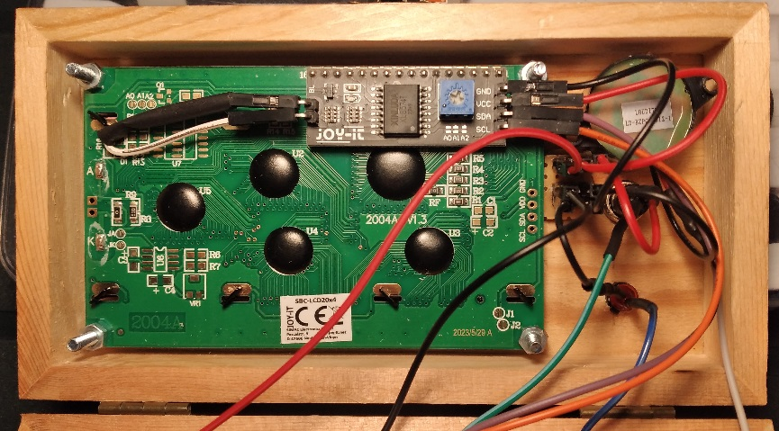
Box cover

